Đề 2 -
LISTENING
https://drive.google.com/file/d/1Cav20u_ru5Ld-xuTRocw__p1E9S5q0lc/view?usp=drive_link

PART 1
Q1 A woman is talking about her house. What is she going to change in their house?
A. The window
B. The car
C. The computer

Q2 A receptionist is checking the client list of a clinic. How many clients are Americans?
A . One
B. Two
C. Three

Q3 Listen to Anna talking about her routine. Where does Anna go for a walk every morning?
A. park
B. neighborhood
C. college

Q4 Listen to a girl calling the cafe. What did the girl forget, and where did she leave it?
A. on the counter
B. in the corner
C. near the door

Q5 Helen is calling a friend about the place her whole family is standing while seeing her off to college. Where are they standing?
A. library complex
B. university area
C. Residential area

Q6 A tour guide is talking about the vacation list of activites. What can people do in the afternoon?
A. Join a dance class
B. Play golf
C. Go shopping

Q7 Doctor's office is calling about a change in the appointment. When is the new appointment?
A . On Thursday 13th
B. On Thursday 30th
C. On Friday 14th

Q8 Alice is calling her friend. What did she lose?
A. A book
B. A laptop
C. A phone

Q9 The woman is calling a friend about meeting for dinner. How long does it take to get to the station?
A. 30 minutes
B. 40 minutes
C. 50 minutes

Q10 Listen to a man talking about their train journey. What time did the train depart?
A. 9:00
B. 9:30
C. 10:00

Q11 Listen to a woman asking about a flight. How much does the flight in the morning cost?
A. 300 pounds
B. 350 pounds
C. 400 pounds

Q12 Listen to a friend talking about selling her music player. How much did she sell it for?
A. 50 dollars
B. 60 dollars
C. 40 dollars

Q13 Listen to a woman explaining why he was late. What is the main reason he gets late?
A. Overslept
B. Forgot something
- C. Missed the train

PART 2.
- Lose weight -
- Improve work performance - A
- As a hobby
- find exercise tiring - B
- have fun exercising with others - C
- hate exercising - D
Speaker A Improve work performance
Speaker B find exercise tiring
Speaker C have fun exercising with others
Speaker D hate exercising

PART 3
Listen to two people discussing Politics. Read the opinions below and decide whose opinion matches the statements, the man, the woman, or both the man and the woman. You can listen to the discussion twice.

1.Young people are more into politics
a.woman b.man c.both
2. Social media change politics.
a.woman b.man c.both
3. People are now better informed on politic.
a.woman b.man c.both
4. More women pursuit politics.
a.woman b.man c.both

W: Politics have been a very common topic lately. I've noticed that young people are becoming much more interested in politics lately. It's great to see them engaging in discussions and activism.
M: I completely agree. It's refreshing to see younger generations taking a stand on important issues.
W: I also think social media plays a big role in this. Platforms like Twitter and Instagram help spread political information quickly and connect people with similar interests.
M: Actually, I believe people are becoming better informed about politics, not because of social media, but through traditional news sources. Many are actively seeking information to understand the issues better.
W: I see your point, but I think social media has a unique impact. It allows for diverse voices to be heard that might not be represented in mainstream media.
M: It's also encouraging to see more women pursuing careers in politics. It brings different perspectives to the table, which is essential for a balanced approach to governance.
W: Absolutely. More representation is always a positive step forward.

PART 4
Listen to a writer talking about her experience in writing and choose the correct answer.

16.1 What does the writer believe helps her the most in her writing process?
A. Writing every day for 15-20 minutes
B. Create dedicated periods for writing
C. Finding a quiet space to work

16.2 What does the writer regret doing during her experience with writer's block?
A. Refuse to seek advice of others
B. Ignoring feedback from editors
C. Writing without a plan

The radio is talking about a musician's career and latest albums. Listen and choose the correct answer.
17.1 What has the musician decided regarding his singing career?
A. He will retire from singing professionally
B. He will make a comeback after a long break
C. He will inform about new albums

17.2 What could the musician have achieved with his recent albums?
A. He could have been more successful
B. He could have inspired future generations in general.
C. He could have gotten a bigger fan base.

READING
Read the email from Henry to his friend, Mark. Choose one word from the list for each gap. The first one is done for you.

Dear Mark,
I just graduated from university.
Now, I (breathe/live/look) ____________ in a flat. I (share/hold/leave) with my friend. We are in the same (squad/headquarter/class) _________ at school.
We (ride/drive/walk) _____________ the car to work together.
In the evenings, we like to (cook/bake/fry) _________ dinner.
We enjoy trying new recipes and cooking together.
It's a fun way to end the day!
See you,
Henry

PART 2
2.1 The sentences below are some instructions. Put the sentences in the right order. The first sentence of the story is an example.

Music show at the park
0. Here are some directions and activities when visiting my place.
5. The local authority planned, sponsored, and paid for everything.
3. Because of this, it was free and five thousand people attended it.
4. Many of them arrived early and visited nearby shops while they were waiting for it to begin.
2. The staff there had a busy day, but they were able to close early and watch the famous singer perform.
1. The local authority planned, sponsored, and paid for everything.He performed for two hours and everyone had great fun

KEY: 53421

2.2 The sentences below are from some instructions. Put the sentences in the right order. The first sentence is done for you.

Visitors day at an animal hospital
0. Please follow the instructions below to ensure you have a wonderful visit at our hospital.

- When you arrive, go straight to the main office to collect your ticket
- You must show this to the member of staff before going to the hospital
- These activities include feeding and playing with the animals
- Before you look at the picture, a guide will tell you about the day's event
- Inside the building, you will see a photograph exhibition
KEY: 13524

PART 3
Four people respond to the interview on their attitude toward art. Read their interviews and answer the questions below.

Person A
I know the names of some famous artists, and I recognize some paintings. However, I only go to exhibitions when my friends want to. I find that seeing exhibitions is often boring, and while I appreciate the skill it takes to create art, I can't help but feel that many galleries lack excitement. Despite this, I do have some artistic techniques myself; I enjoy painting in my free time but I prefer to create rather than just observe.
Person B
I think that looking at art is a personal experience. I much prefer to see art on my own, where I can take my time to appreciate each piece without distractions. I think visitors to galleries should focus more on the art itself rather than chatting or using their phones. When I'm alone with a painting, I can truly connect with it and reflect on what the artist intended.
Person C
I find art fascinating. I have developed a good knowledge about various art movements and techniques over the years. Each piece tells a story, and I love discovering the history behind them. The colors, forms, and emotions captured in art pieces captivate my imagination. I could spend hours discussing and analyzing art, and I always look forward to learning more.
Person D
I have great memories associated with art, as I have been going to numerous art exhibitions in my whole life. I cherish the moments spent with friends and family, exploring galleries together. Seeing art with people close to me adds a special dimension to the experience; we share our thoughts and feelings about the pieces we encounter. These shared experiences have created lasting bonds and wonderful memories.

- Who has some artistic skills? A
- Who prefers seeing art by themselves? B
- Who has a good knowledge about art? C
- Who thinks visitors to the galleries should focus more on the art? B
- Who likes seeing art with others? D
- Who has been going to art exhibitions all their life? D
- Who thinks seeing an exhibition is boring? A

Part 4:
1 – A way of life now out date
2 – Benefits for employees
3 – Undesirable financial consequences
4 – Unforeseen challenges for employees
5 – Difficult to change old habits
6 – An unfair plan for some people
7 – Alternative solutions worth considering

SPEAKING
PART 1
In this part, I am going to ask you three short questions about yourself and your interests. You will have 30 seconds to reply to each question.
Begin speaking when you hear this sound.
Q1 Please tell me about your favorite place.
Q2 Please tell me about your favorite film star.
Q3 Please tell me about the last time you saw an advertisement.

PART 2
In this part, I'm going to ask you to describe a picture. Then I will ask you two questions about it. You will have 45 seconds for each response.
Begin speaking when you hear this sound.
Q1 Describe this picture
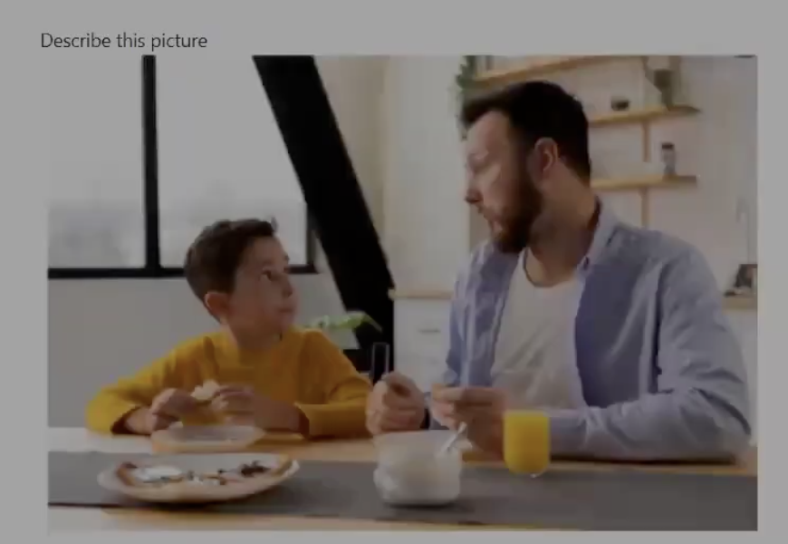
Q2 What do you eat for breakfast?
Q3 Do you think people should eat breakfast?

PART 3
In this part, I'm going to ask you to compare two pictures, and I will then ask you two questions about them. You will have 45 seconds for each response.
Begin speaking when you hear this sound.

Q1 Describe 2 pictures
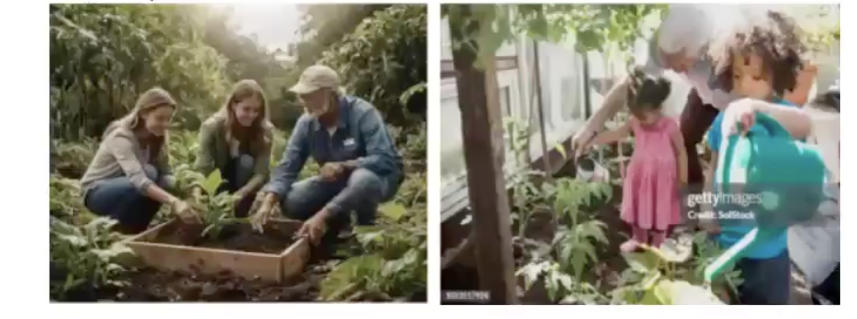

Q2 What are the attractions of the two pictures?
Q3 What is the appeal of growing plants and doing gardening?

PART 4
Q1 Describe a time when you visited someone.
Q2 What do you think about having unexpected visitors?
Q3 Some people like to live in small communities, while others like to live in big cities. What is your opinion?

WRITING

PART 1
You want to join a Computer club. You have 5 messages from a member of the club. Write short answers (1-5 words) to each message.
Recommended time: 3 minutes.
Example: How are you? I'm fine, thanks.

Q1 What is your favourite colour?
my favourite colour is pink
Q2 What is your favourite time of the year?
holiday is my favourite time of the year
Q3 What is your favourite time of the year?
Q4 What do you like to do in the evening?
i do my homework
Q5 What is the weather like today?
it is very hot

PART 2
You are a new member of the Computer club. Fill in the form. Write in sentences. Use 20-30 words.
Recommended time: 7 minutes.

When and where do you usually use a computer?
i usually use a computer when i go to school.because it helps me search information or learn new something.

PART 3
You are communicating with other members of the club in the chat room. Reply to their questions.
Write in sentences. Use 30-40 words per answer. Recommended time: 10 minutes.

A. Kim: I love new technology. Can you please tell me about the last time you used computer to do something?
hi kim!Last time i used computer was yesterday.i need computer to search information about my course.And i watching movie in my computer and chat my friend or call my friend when i finish work.
B. Marco: My grandmother doesn't know anything about computers? How can she learn about them? What should she do?
i think she can start with basic class or ask family to help her.watching videos on youtube is also good.she should learn step by step and not worry if it is hard at frist.
Bà có thể bắt đầu với lớp học cơ bản hoặc nhờ người thân giúp. Xem video trên YouTube cũng rất tốt. Bà nên học từng bước và đừng lo nếu ban đầu khó.

C. Sylvia: Young people spend too much time using computers. Some say it is not good for them. What is your opinion?

hi sylvia! i think using computer too much is not good.because young people should go outside play sport and talk to friends.Computer are helpful but we need to take breaks and do other thing too
chào Sylcia! tôi nghĩ sử dụng máy tính quá nhiều thì không tốt.Bởi vì người trẻ nên ra ngoài,chơi thể thao hoặc nói chuyện với bạn.Máy tính thì có ích nhưng chúng ta cần nghỉ và làm việc khác.
PART 4
You are a member of the Computer Club. You received this email from the club's manager.

Dear members,
We are making some changes to the website because we want more people to join us. As you know, the website at the moment is very simple and we would be interested to hear some ideas about ways to make it more attractive and why you think it would attract more visitors.
Bests,
Club Manager.

Write an email to your friend, who is also a member of this club. Tell your friend about your opinion and why. Write about 50 words

hi Alex
how are you these day! i have got received your letter changes to the website because we want more people to join us.
i am very happy to talk my idea. i think we need changed the interface to be more eye-catching and many more changes.
i will give you my contact 123456789
i am looking forward to your reply.

Write an email to the manager of the club. Tell the manager about your opinion and why. Write about 120-150 words.
dear club manager.
my name is lam du anh tu, thank for your email about changes to the website because we want more people to join us. As you know, the website at the moment is very simple and we would be interested to hear some ideas about ways to make it more attractive and why you think it would attract more visitors.
i am very interesting when hearing about the new.
i think the club need changed interface to eye-catching and added more functions to the program this wedsite.As well as make it easier for users and in it should add some games to make it more special.
i am looking to forward to your reply.i hope my comments can help the club a little.
best regards.

Transcript Listening:
- I've always loved the ocean. That is why I initially wanted to install a big window that looks out to the river at my house. But now my husband and I realized it was too big and now too much sunshine got in. My car got heated and the computer next to the window always seemed like it would explode. I have no choice but to change it into another window that can close entirely.
- Alrigh Let me go over the list of clients for today. We've got Carl, Harry and Matthew, all from the uk. Leslie who's from the US is also scheduled for an appointment. Then we have two more clients coming in from France. So that gives us one American, a few from the UK and the rest from France. It looks like everything'in order.
- I really like to walk in the mornings every day I take a nice walk before my classes start. I could walk around my neighborhood, but I prefer going to college. It's a great way for me to get a bit of exercise and clear my mind before the day begins. The campus is so peaceful in the mornings.
- Hi, I was at your cafe this afternoon and I think I left something there. I remember having it when I sat at a small table in the corner and I checked the counter and near the door before I left but I must have forgotten it in the corner after all. Could you please look there?
- Hi, I just wanted to call quickly before we head off. My family is all here to see me and were standing in this big area with lots of houses and apartments. Its a nice residential area with some trees and small shops nearby. Were not right by the university but it's close enough. There are lots of other students and families here too. Saying goodbye. It feels a bit emotional but I'm also really excited to start this new journey.
- Now lets talk about the afternoon activities. For those interested, we have a golf course available where you can spend your afternoon playing golf. If golf isn't your thing, don't worry. There's also a dance class scheduled in the evening and of course you can always go shopping in the nearby stores later on. But bear in mind the store will only open in the morning.
- Hello, this is the doctor's office calling to change your appointment. I wanted to let you know that the new appointment is on Thursday the 13th. I understand you might have been expecting it to be on Friday the 14th, but we're all off this day due to the national dentist holiday. Please let us know if that works for you.
- Hey, it's Alice. I think I might have left something at your house. I had my book with me. It's in my backpack. My laptop's here too, but I can't find my phone anywhere. Did you happen to see it after I left? I think I might have left it on the table.
- I'm excited about dinner tonight. I just need to check how long it takes to get to the station. Hmm. I think it takes about 40 minutes if I walk quickly. I should leave soon so I don't miss the train or else that would be another 30 minutes. I can't wait to try that new restaurant. It's going to be great.
- This morning was rough at the station. I thought the train would leave around 9 o'clock but I heard it would be delayed. It finally departed at 9:30 though some people said it might be even later. Usually if it'delayed it could leave as late as 10 o'clock. I'm glad it didn't take that long today.
- I'm looking at flights and comparing prices. The morning flight I want is £350 which is a bit more than the £300 pound one later in the day. There's also another option that costs 400 pounds but it includes extra services I don't need, so I think I'll stick with the 350 pound one since it leaves at the right time for me.
- I sold my old music player last week. I considered selling it for around $60 since it was in good condition, but I thought $40 would be a bit too low. I finally sold it for $50 which felt just right. Now I have a bit of extra cash to save or spend on something new.
- I've been late several times recently. Sometimes I oversleep, but that wasn't the case today. I actually left on time, but I missed the train at the last minute. It's always the main reason I end up late. I try to double check everything I need, so forgetting something isn't usually an issue for me either.

Person A: Exercise has become essential in my life, especially with my demanding and stressful job. The workload can be overwhelming at times, leaving me feeling exhausted and overwhelmed. That's why I turn to exercise as a way to unwind and rejuvenate.
Whether it's going for a run, practicing yoga, or even just taking a brisk walk, exercise helps me release stress and clear my mind. I've noticed that after exercising, I feel more focused, energized, and ready to tackle my work with renewed vigor. It's incredible how something as simple as exercise can greatly improve my work performance and overall well-being.

Person B: Honestly, exercise wears me out. The idea of getting all sweaty and sore doesn't excite me at all. Every time I try to work out, it feels like I'm running on empty within minutes. And people say it gives them energy. Are we talking about the same thing? I feel more tired just thinking about the treadmill. I know it's supposed to be good for me, and I try to do it for my health, but I don't get that rush people talk about. Exercise for me is just exhausting. Why do something that makes me want to lie down for three days afterward?

Person C: Exercising is a blast when you're with the right people. I've joined a few group classes, and they're like a party every time.
The music is pumping, everyone's in sync, and it feels like we're all in this together. Working out alone can get boring, but with friends, you laugh, you encourage each other, and suddenly an hour has flown by. We push each other, you know? It's kind of amazing.
Half the time I forget I'm even working out. I actually look forward to it. The camaraderie makes it worth every minute.

Person D: Exercise? I can't stand it. I know it's supposed to be good for you and all that, but I find it completely miserable. The sweat, the strain, the way my muscles burn afterward. It's like a punishment. People say it'll get better or that I'll start to like it eventually, but I've tried, and I still hate it. Honestly, life's too short to spend it doing something you can't stand. There are other ways to be healthy that don't involve torturing myself. I'd rather read a book than jog any day.

Woman: Politics have been a very common topic lately. I've noticed that young people are becoming much more interested in politics lately. It's great to see them engaging in discussions and activism.
Man: I completely agree! It's refreshing to see younger generations taking a stand on important issues.
Woman: I also think social media plays a big role in this. Platforms like Twitter and Instagram help spread political information quickly and connect people with similar interests.
Man: Actually I believe people are becoming better informed about politics not because of social media but through traditional news sources. Many are actively seeking information to understand the issues better.
Woman: I see your point, but I think social media has a unique impact. It allows for diverse voices to be heard that might not be represented in mainstream media.
Man: It's also encouraging to see more women pursuing careers in politics. It brings different perspectives to the table, which is essential for a balanced approach to governance.
Woman: Absolutely! More representation is always a positive step forward.

Hi, everyone.
I'd like to share my experience with writer's block during the process of writing my new bestseller. Many people think that to write well, you need to sit down every day for 15 to 20 minutes or find a quiet space. While those strategies work for some, I've found that establishing specific time slots for writing that truly fit my style is what helps me the most.
However, I did face significant writer's block at one point, and looking back, I regret not reaching out for guidance from others. I thought I could handle everything on my own, but sometimes it's vital to get an outside perspective. Talking to fellow writers and mentors could have helped me overcome that block much faster.
Now I understand that collaboration and sharing ideas can inspire creativity. So if you ever find yourself stuck, don't hesitate to reach out to others.

Good afternoon, everyone.
Today, we're diving into the life of a beloved musician who has decided to retire from singing professionally. Unlike in the past, where he would inform his fans and then make a comeback, this time he's serious about stepping away for good. His talent has always shown through, and many believe he could have achieved even greater success with his recent albums.
However, the long break he took between projects made it difficult for him to regain his previous momentum. Fans were excited to see him return, but the gap left some wondering if he could still capture the magic he once had. As he prepares for this new chapter in his life, we can only reflect on the incredible music he's given us over the years.
He leaves behind a rich legacy that will inspire future generations of artists. Stay tuned for more updates on this iconic musician

